Experiment Number : 9 Date: 25.02.2026

Implementation of a Java Program to import packages using different methods

Aim:
Write a Java program to import packages using different methods for different use cases.

PRE LAB EXERCISE
QUESTIONS
- How to import a single class and multiple classes from a package in Java?
• A single class can be imported using import package_name.ClassName;
• Example: import java.util.Scanner;
• All classes in a package can be imported using import package_name. *;
• Example: import java.util.*.

- Which package is always imported by default in every Java class?
• java.lang is automatically imported in every Java program
• It provides fundamental classes required for program execution
• It contains classes like String, System, Math, and wrapper classes
• No explicit import statement is needed for this package

IN LAB EXERCISE
Objective
To understand and implement the Java packages using different methods and import them.
Problem
Define a package named ‘useFul’ with a class names ‘UseMe’ having following methods:
1) area ()- To calculate the area of given shape.
2) salary ()- To calculate the salary given basic Salary,da,hRA.
3) percentage ()-To calculate the percentage given total marks and marks obtained.
4) Develop a program named ‘Package Use’ to import the above package ‘useFul’ and use the method area ().
5) Develop a program named ‘manager’
Source Code
//Package Creation:
package useFull;
import java.util.*;

public class UseMe {

Scanner obj = new Scanner(System.in);

// ----------- AREA METHOD -----------
public void area() {

class Method {

void aos(int a) {
System.out.println("\nArea of square with length " + a + " is " + (a * a));
}

void aor(int a, int b) {
System.out.println("\nArea of rectangle with dimensions " + a + " & " + b + " is " + (a * b));
}

void aoc(int r) {
double a = 3.14 * r * r;
System.out.println("\nArea of circle with radius " + r + " is " + a);
}

void aot(int a, int b) {
float ar = (a * b) / 2.0f;
System.out.println("\nArea of triangle with dimensions " + a + " & " + b + " is " + ar);
}
}

Method m = new Method();

System.out.println("\n1.Square\n2.Rectangle\n3.Circle\n4.Triangle\nSelect the shape");
int ch = obj.nextInt();

switch (ch) {

case 1:
System.out.print("\nEnter the length of side of square : ");
int s = obj.nextInt();
m.aos(s);
break;

case 2:
System.out.print("\nEnter the dimensions of rectangle : ");
int l = obj.nextInt();
int b = obj.nextInt();
m.aor(l, b);
break;

case 3:
System.out.print("\nEnter the radius of circle : ");
int r = obj.nextInt();
m.aoc(r);
break;

case 4:
System.out.print("\nEnter the dimensions of triangle : ");
int ba = obj.nextInt();
int w = obj.nextInt();
m.aot(ba, w);
break;

default:
System.out.println("Invalid choice");
}
}

// ----------- SALARY METHOD -----------
public void salary() {

int ba, da, hra;

System.out.print("\nEnter the basic salary : ");
ba = obj.nextInt();

System.out.print("\nEnter the dearness allowance : ");
da = obj.nextInt();

System.out.print("\nEnter the house rent allowance : ");
hra = obj.nextInt();

System.out.println("\nThe total Gross salary of employee is : " + (ba + da + hra));
}

// ----------- PERCENTAGE METHOD -----------
public void percentage() {

int n, sum = 0;
float p;

System.out.print("\nEnter the total number of subjects : ");
n = obj.nextInt();

int m[] = new int[n];

System.out.print("\nEnter the marks of " + n + " subjects : ");

for (int i = 0; i < n; i++) {
m[i] = obj.nextInt();
sum += m[i];
}

p = (float) sum / n;

System.out.println("\nPercentage of student : " + p);
}

// ----------- CLOSE SCANNER -----------
public void close() {
obj.close();
}
}
//Package Implementation-1:
import useFull.UseMe;
class packageUse
{
public static void main(String args[])
{
UseMe o=new UseMe();o.area();
}
}

Output
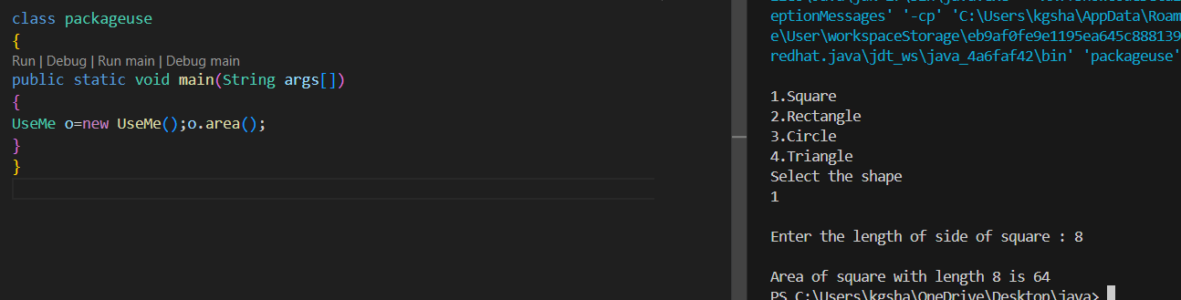//Package Implementation-2:
import useFull.UseMe;
class manager
{
public static void main(String args[])
{
UseMe obj=new UseMe();obj.salary();
}
}

Output
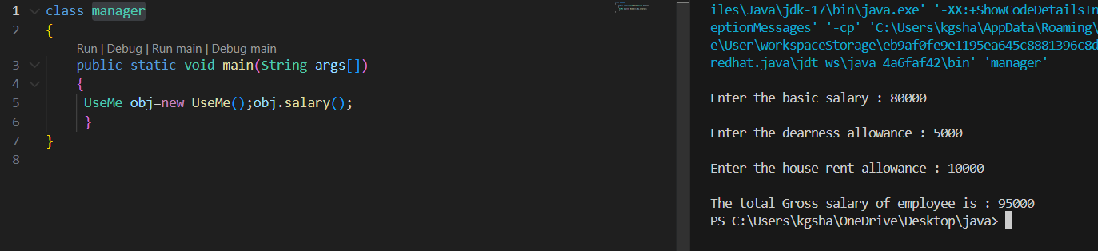
POST LAB EXERCISE
- Find the key differences between java.util and java.lang packages.
• java.lang is imported by default, whereas java.util must be imported explicitly
• java.lang contains core language classes, while java.util contains utility and collection classes
• java.lang includes String, System, Math, whereas java.util includes Scanner, Date, Random
• java.lang is used for basic operations, while java.util is mainly used for data handling and collections

- List some of the subpackages of java.util
java.util.concurrent
• Provides support for multithreading and concurrent programming
• Contains utilities like Executor framework and concurrent collections
java.util.regex
• Used for pattern matching with regular expressions
• Provides classes like Pattern and Matcher for string validation and searching
java.util.stream
• Processes data from collections using functional operations
• Supports sequential and parallel data processing
java.util.logging
• Used for logging application events and errors
• Provides different logging levels such as INFO, WARNING and SEVERE

ASSESSMENT

Description | Max Marks | Marks Awarded
Pre Lab Exercise | 5
In Lab Exercise | 10
Post Lab Exercise | 5
Viva | 10
Total | 30
Faculty Signature

